Practical – 1

AIM :Implement Web Service using java

- Create Web Application in NetBeans
File > New Project > Java Web > Web Application
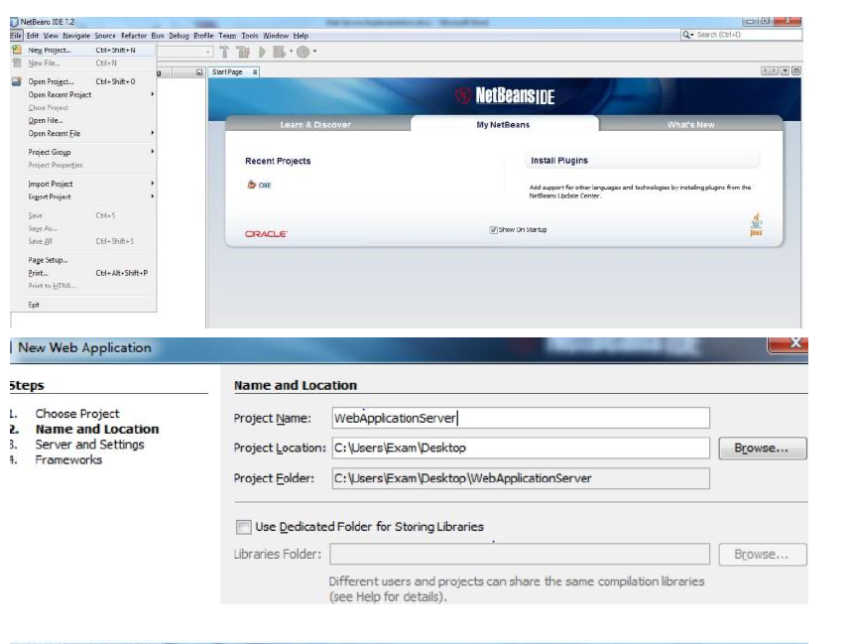
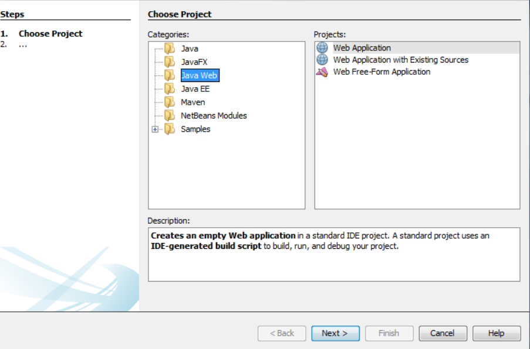

Click Next and Finish.
- Create Java Packages from
Web Application > Source Packages > New > Java Package

- Specify Name of Java Package and click on Finish Button

- Right Click on Package and create web service
New > Web Service

- Specify Name of Web service and select Java Package
Web Services Folder is created

- Under Web Services Folder Select Web service and Right click > Add Operation
- Add Operation
Specify Name of Operation and click on OK

- You May also add operation with parameters

- Modify Method according to requirement.. like I want to return string is UVPCE and perform sum operation then code
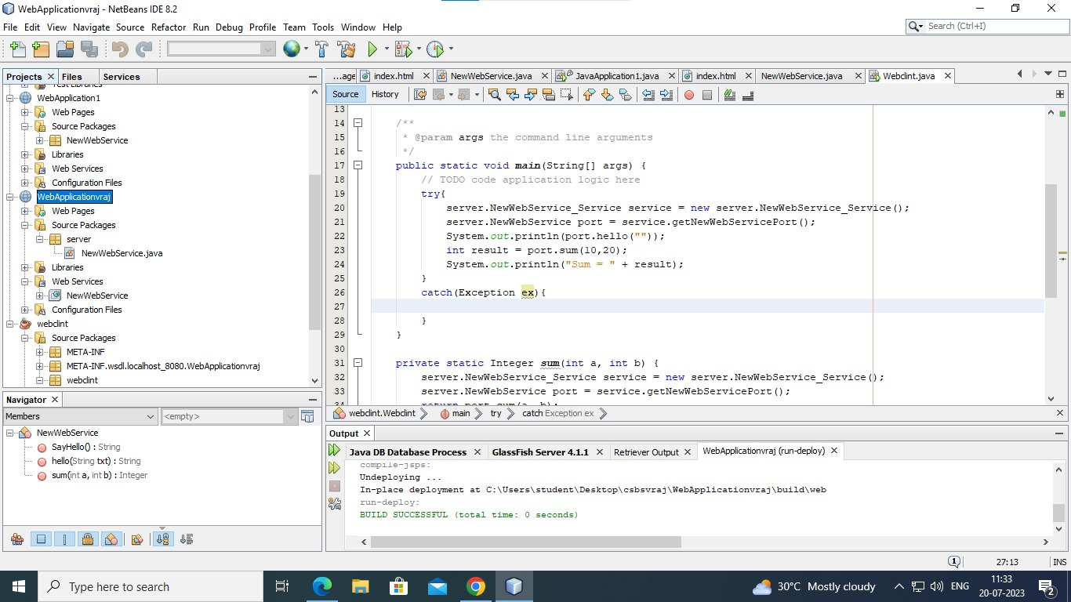

- Deploy Project

For Successful deployment
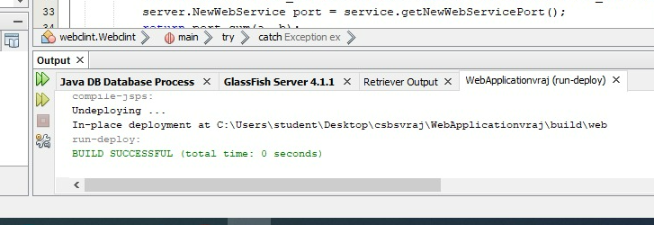

- Test Web Service

Output of Test Web service in web Browser
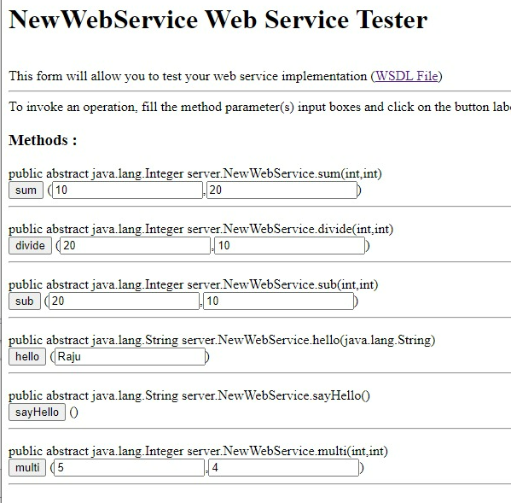
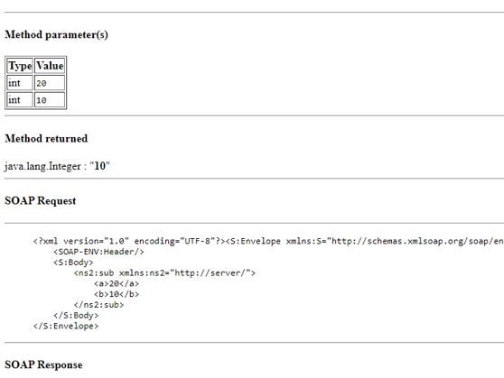

- Click on WSDL File Link and copy newly open window URL
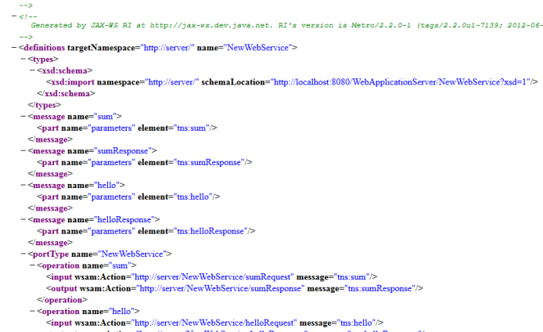

- Create Simple Java Application from File > New > Java > java Application
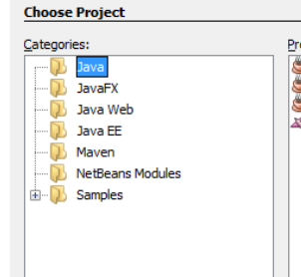
- Specify Name and Finish
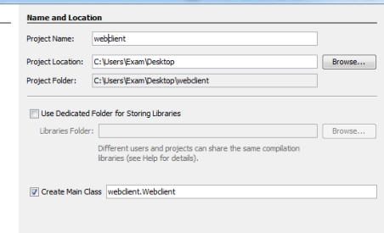

- Add Web Service Client from
Client Project > Source Package > New > Web Service Client

- Add WSDL and click on Finish

- Open code of java file and Right click > Insert Code
Then Select Call Web Service Operation
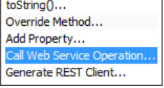

- Select Operation from Web Service
